**UPDATED Summary of CONDITIONED operating models for atlantic bluefin tuna**

Tom Carruthers[1], Doug Butterworth[2]

*SUMMARY*

Bluefin tuna operating models were revised and refitted to data in order to: (1) account for a longer time period for which index data are available; (2) provide an improved interpretation of stock mixing data; (3) better represent assessment estimates of historical stock trends and (4) approximate uncertainties over the strength of past and future recruitment. A total of 36 reference case operating models for Atlantic bluefin tuna are described. The fits of these models to data are presented in this paper. The various operating models fitted similarly well to the indices and none appeared to warrant rejection from the reference set with the exception of OM #14. The fitted reference operating models span a reasonably wide range of estimates for stock status and productivity, which may render the third current abundance option unnecessary. The fishery-independent and CPUE indices currently proposed for use for generating future data to use an input to Candidate Management Procedures, which span younger and older life stages in both eastern and western areas, had acceptable fitting diagnostics.

*KEYWORDS*

*Management Strategy Evaluation, bluefin tuna, operating model, management procedure*

# Introduction

A Management Strategy Evaluation (MSE, Butterworth and Punt 1999, Cochrane 1998) approach has been proposed for Atlantic bluefin tuna as a suitable framework for providing robust management advice consistent with the precautionary approach (GBYP 2017a). A principal task in the construction of an MSE framework is the development of operating models which represent credible hypotheses for population and fishery dynamics. Operating models are typically fishery stock assessment models which are fitted to data to ensure that model assumptions and estimated parameters are empirically credible (Punt et al. 2014, e.g. CCSBT 2011).

A general approach for testing MPs using MSE established two sets of operating models. The reference set of trials are considered to reflect the most plausible hypotheses which also have a marked impact on stock dynamics, and are the primary basis for identifying the best performing management procedure. Robustness trials are used to determine whether the management procedure behaves adequately in scenarios that are less likely.

Following feedback from the 2018 ICCAT Bluefin tuna species group MSE intersessional meeting, the reference bluefin tuna operating models were revised and refitted. The objectives were to: (1) account for a longer time period for which index data are available, (2) provide an improved interpretation of stock mixing data; (3) represent assessment estimates of historical stock trends better and (4) approximate uncertainties over the strength of past and future recruitment. In this paper we describe the fit of these new models to data (their “conditioning”).

# Methods

Seasonal, spatial, multi-stock, age structured operating models were fitted to a wide variety of fishery dependent and independent data (see Carruthers et al. 2015a and CMG 2017). Such data included electronic tags, Task II catch rate data, and micro-constituent and genetic data informing stock of origin (for a summary of these data see Carruthers et al. 2015b and GBYP 2017b).

A reference set of operating models was identified that spanned three main axes of uncertainty for Atlantic bluefin tuna: (1) future recruitment, (2) abundance and its trends, and (3) age-at-maturity (spawning fraction) / natural mortality rate (see Tables 1 and 2 for the reference operating model set design). Although this leads to 36 reference set operating models in total, two of the future recruitment scenarios arise from the same historical model fitting (levels 1 and 3). Furthermore the third level for factor abundance (the somewhat arbitrary tuning for greater depletion of the two stocks than estimated by the best fit to the data) is not yet presented (given substantial changes in stock status estimates since April for the scenarios now presented, these would seem to merit further scrutiny as to whether they already provide a sufficiently wide range of possibilities before proceeding further). Consequently, just 16 model fits are presented here (the unshaded rows of Table 2).

# Results

**Model estimates for the base-case reference model #1**

Operating model #1 consists of the first levels of all factors (hence including option A for current abundance), namely maximum posterior density ‘best’ estimate of abundance from the operating model (with no additional priors as for abundance factor levels B or C), low age at maturity and high natural mortality rate. For this reference case OM the model provides estimates of eastern area biomass that are similar to those from the VPA and Stock Synthesis (SS) assessments (Figure 1a). The trend however is more positive than for those assessments and follows an upward trajectory over 1988 – 2015. However, the very recent 3-fold increase in spawning biomass for the eastern stock that is estimated by the VPA assessment is greater than that for the fitted OM #1.

OM #1 estimates of western area spawning biomass are on average about triple those from the VPA and SS assessments (Figure 1a). The trend in spawning biomass is also different showing maximum biomass around 2003 rather than 2015 for the two assessments (this mismatch should be seen in the overall context that the abundance of bluefin in the eastern area is much greater- by almost an order of magnitude - than that in the western area).

**Mimicking assessments: base case reference model #4 (factor abundance, level B)**

OM #4 is a departure from OM #1 in that it uses priors to obtain similar abundance and trends in East and West areas to the VPA assessments (OM #4, factor abundance level B). Figure 1b shows that these prior specifications were largely successful in attaining their objectives and that M3 SSB by area follows the VPA well for most OMs.

**Fit to indices of abundance**

The candidate indices for use in the CMPs showed reasonable fits comparable to those of current stock assessments (Figures 2a and 2b) and fits were not strongly different among operating models (Figures 3a – 3f).

**All OM model estimates**

In general, the 16 fitted operating models span a reasonably wide range of simulated stock parameters and biomass trajectories. MPD model estimates of apical FMSY ranged from 0.08– 0.28 for the Eastern stock (Table 3a, Figures 4a and 4b) and 0.04-0.1 for the Western stock (Table 3b). Stock depletion at present (current SSB relative to its unfished level) ranged from 0.06-0.23 for the East stock and 0.16 – 0.41 for the Western stock (Tables 4a and 4b have the same results for operating model #4).

**Statistical properties of indices**

In order to simulate realistic relative abundance indices it is necessary to characterize the properties of operating model fitting to these data. Two principal properties are residual error and auto-correlation in residual errors. These specify the degree of annual error in simulated indices in addition to the propensity to simulate runs of residuals where the index is above or below the true relative biomass for multiple years (Table 5 lists values for the indices accepted for use in CMPs; those values were computed from the residual series for the Reference Case fit OM #1).

# Discussion

In general, the various reference set operating models span a reasonably wide range of scenarios for stock status and productivity. While even the best fits to indices showed some residual patterns, the observation model can account for misfit by simulating auto-correlation in residuals.

The principal purpose of this document is to investigate whether certain operating models do not meet acceptable standards of model fit. The various operating models fitted similarly well to the indices and none appeared to warrant rejection from the reference set.

# Acknowledgements

This work was carried out under the provision of the ICCAT Atlantic Wide Research Programme for Bluefin Tuna (GBYP), funded by the European Union, several ICCAT CPCs, the ICCAT Secretariat and by other entities (see: http://www.iccat.int/GBYP/en/Budget.htm). The contents of this paper do not necessarily reflect the viewpoints of ICCAT or other funders and in no ways anticipate ICCAT future policy in this area.

# References

ABT-MSE. 2017. Atlantic bluefin tuna management strategy evaluation: an R package. Available at: [accessed September 2017]

Butterworth, D.S., Punt, A.E., 1999. Experiences in the evaluation and implementation of management procedures. ICES J. Mar. Sci. 56, 985-998.

Carruthers, T.R., Kimoto, A., Powers, J., Kell, L., Butterworth, D., Lauretta, M. and Kitakado, T. 2015a. Structure and estimation framework for Atlantic bluefin tuna operating models. ICCAT SCRS/2015/179.

Carruthers, T.R., Powers, J., Lauretta, M., Di Natale, A., Kell, L. 2015b. A summary of data to inform operating models in management strategy evaluation of Atlantic bluefin tuna. ICCAT SCRS/2015/180.

CMG. 2017. Specifications for MSE trials for bluefin tuna in the North Atlantic. GBYP Core Modelling Group. ICCAT Atlantic Wide Research Programme for Bluefin Tuna. Available at: [https://github.com/ICCAT/abft-mse/tree/master/Manuals_and_design_documents/Trial Specifications.docx](https://github.com/ICCAT/abft-mse/tree/master/Manuals_and_design_documents/Trial%20Specifications.docx) [accessed September 2017]

GBYP. 2017a. ICCAT Atlantic wide research programme for Bluefin Tuna. Available online at: http://www.iccat.int/GBYP/en/index.htm [accessed September 2017]

GBYP. 2017b. Data to inform operating models for North Atlantic bluefin tuna. ICCAT Atlantic Wide Research Programme for Bluefin Tuna. Available at: <https://drive.google.com/drive/folders/0B0TXcs-MLRl3anc2Sjc0Yjk1ZTA> [accessed September 2017]

Cochrane, K L., Butterworth, D.S., De Oliveira, J.A.A., Roel, B.A., 1998. Management procedures in a fishery based on highly variable stocks and with conflicting objectives: experiences in the South African pelagic fishery. Rev. Fish. Biol. Fisher. 8, 177-214.

Punt, A.E., Butterworth, D.S., de Moor, C.L., De Oliveira, J.A.A., Haddon, M., 2016. Management strategy evaluation: best practices. Fish Fish. 17, 303–334, http://dx.doi.org/10.1111/faf.12104.

## Table 1. The factors and associated levels which define the reference set of operating models. Three major uncertainty axes: future recruitment; current abundance; and natural mortality/maturity (in combination) for conditioning and projections. These axes assume that the options of East and West are linked across rows of the table below. This is done with the intention of capturing extremes. The West recruitment scenarios are intended to capture two alternative hypotheses for historical recruitment: the ‘high then low recruitment’ hypothesis captured by level 1 in which a Beverton-Holt stock recruitment relationship with fixed moderate steepness (R0 estimated) shifts to a hockey-stick model after 1975 (second R0 estimated), and the he ‘high recruitment’ hypothesis that maintains a Beverton-Holt recruitment relationship with fixed moderate steepness throughout the time series. The third level for West recruitment evaluates the robustness of MPs to a future shift between these alternative recruitment scenarios.

|  |  |  |
| --- | --- | --- |
|  | West | East |
| Future recruitment | |  |
| 1 | Hockey-stick | 88+ B-H with *h*=0.98 |
| 2 | B-H with *h* estimated | 88+ B-H with *h*=0.70 |
| 3 | Hockey-stick changes to  B-H after 10 years | 88+ B-H with *h*=0.98 changes to 50-87 B-H with *h*=0.98 after 10 years |
| Abundance | |  |
| A | Best estimate | |
| B | East and West area spawning biomasses match VPA assessments | |
| C | Stocks are subject to more pronounced depletion than estimated | |
| Maturity (both stocks) | | Natural Mortality (both stocks) |
| I | Younger | High |
| II | Younger | Low |
| III | Older | High |
| IV | Older | Low |

## Table 2. The design of reference set of operating models. Note that only future recruitment factor levels 1 and 2 are presented in this paper (level 3 is identical to level 1 in model fitting), and further that abundance factor abundance level C is also not included.



**Table 3a**. Reference case operating model #1 estimates (maximum posterior density) for the Eastern stock based on 2015 (most current) estimates of size selectivity and dynamic B0 (the spawning biomass under zero fishing accounting for shifts in recruitment). OM refers to the operating model umber (Table 2). Reference points for the Eastern stock using 2015 stock-recruitment (R0 and steepness). FMSY refers to apical F (the instantaneous fishing mortality rate on the most selected length class). UMSY is current yield divided by vulnerable biomass. Tabulated biomass numbers (BMSY, BMSY_B0 and B2015) refer to spawning biomass. These biomass numbers and MSY numbers are expressed in thousands of tonnes. Depletion is spawning biomass in 2015 relative to the ‘dynamic B0’.

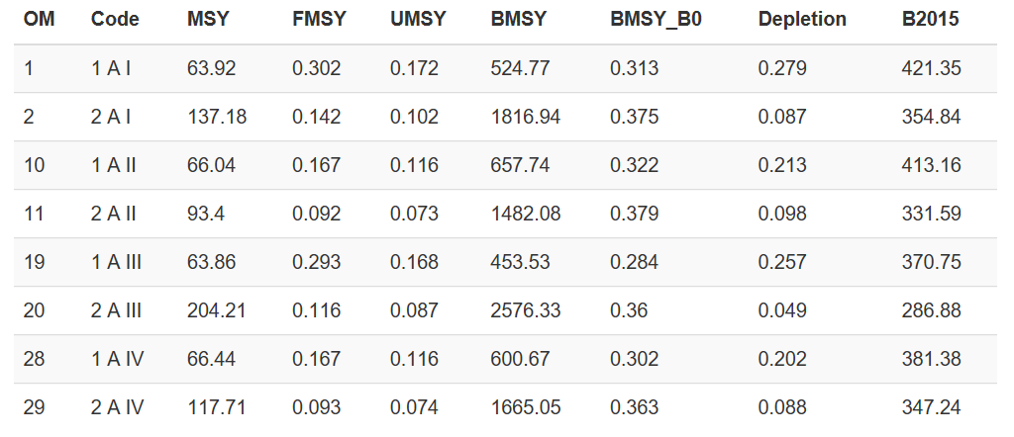

**Table 3b**. As Table 3 but for the Western stock.

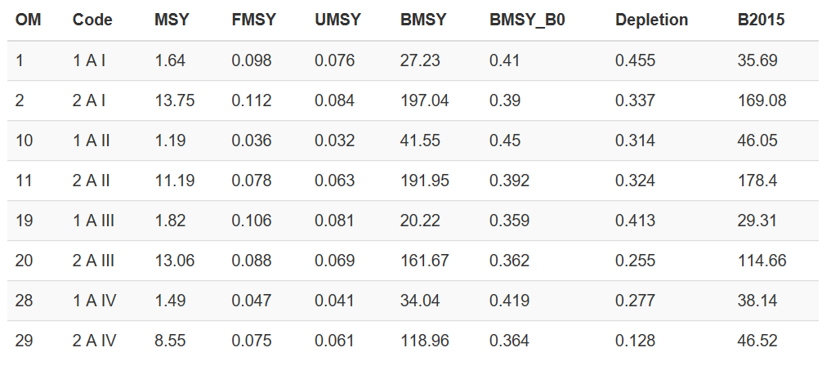

**Table 4a**. Operating model #4 (as reference case #1 but matches VPA trends, abundance level B) estimates (maximum posterior density) for the Eastern stock based on 2015 (most current) estimates of size selectivity and dynamic B0 (the spawning biomass under zero fishing accounting for shifts in recruitment). OM refers to the operating model umber (Table 2). Reference points for the Eastern stock using 2015 stock-recruitment (R0 and steepness). FMSY refers to apical F (the instantaneous fishing mortality rate on the most selected length class). UMSY is current yield divided by vulnerable biomass. Tabulated biomass numbers (BMSY, BMSY_B0 and B2015) refer to spawning biomass. These biomass numbers and MSY numbers are expressed in thousands of tonnes. Depletion is spawning biomass in 2015 relative to the ‘dynamic B0’.

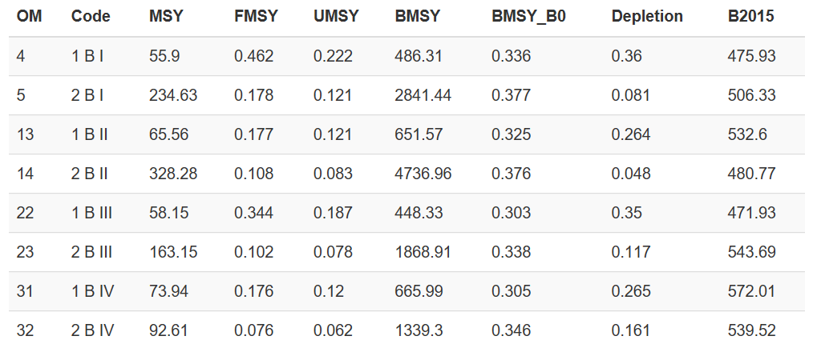

**Table 4b**. As Table 3 but for the Western stock.

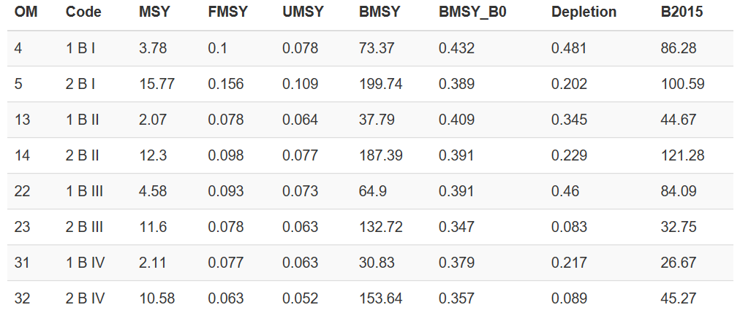

**Table 5.** Statistical properties of fits (reference case operating model #1) to indices agreed to be projected to allow their use in CMPs. Residual error is expressed as a standard deviation of the log-space observed – predicted values. Auto. Cor. is lag-1 autocorrelation in log residuals.

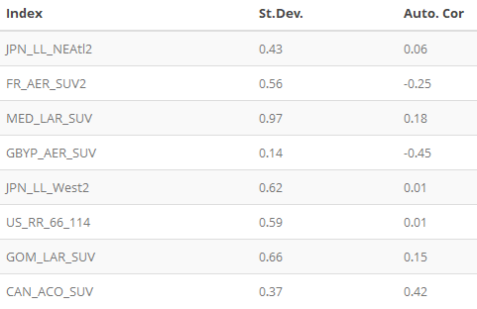

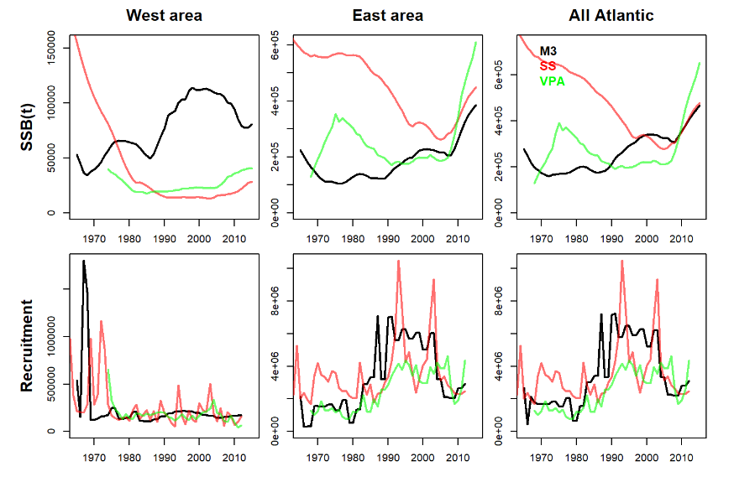

**Figure 1a.** Similarity of M3 operating model estimates (OM #1, with abundance factor level A) with Western and Eastern assessments (2017).

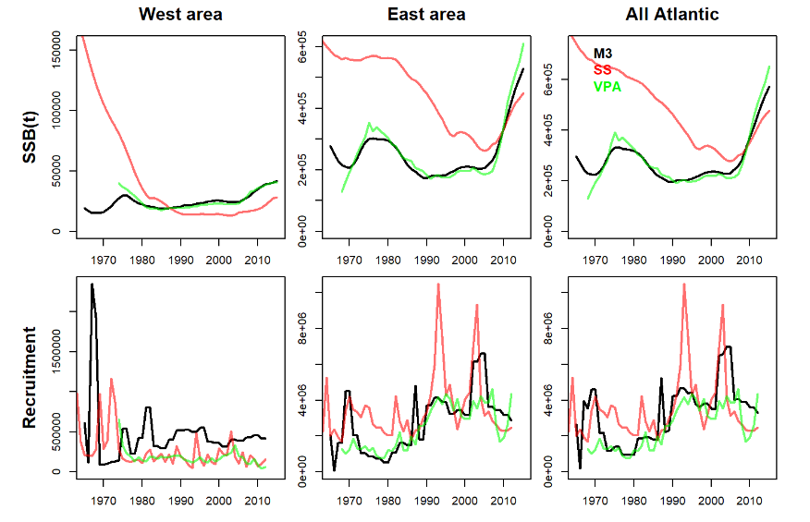

**Figure 1b.** Similarity of M3 operating model estimates (OM #4) with Western and Eastern assessments (2017). This operating model differs from OM#1 (Figure 1a above) in that it corresponds to level B for factor 2 (abundance) and the mean spawning biomass levels in absolute terms in the East and West areas over the full time series have an informative prior that matches the VPA assessments.

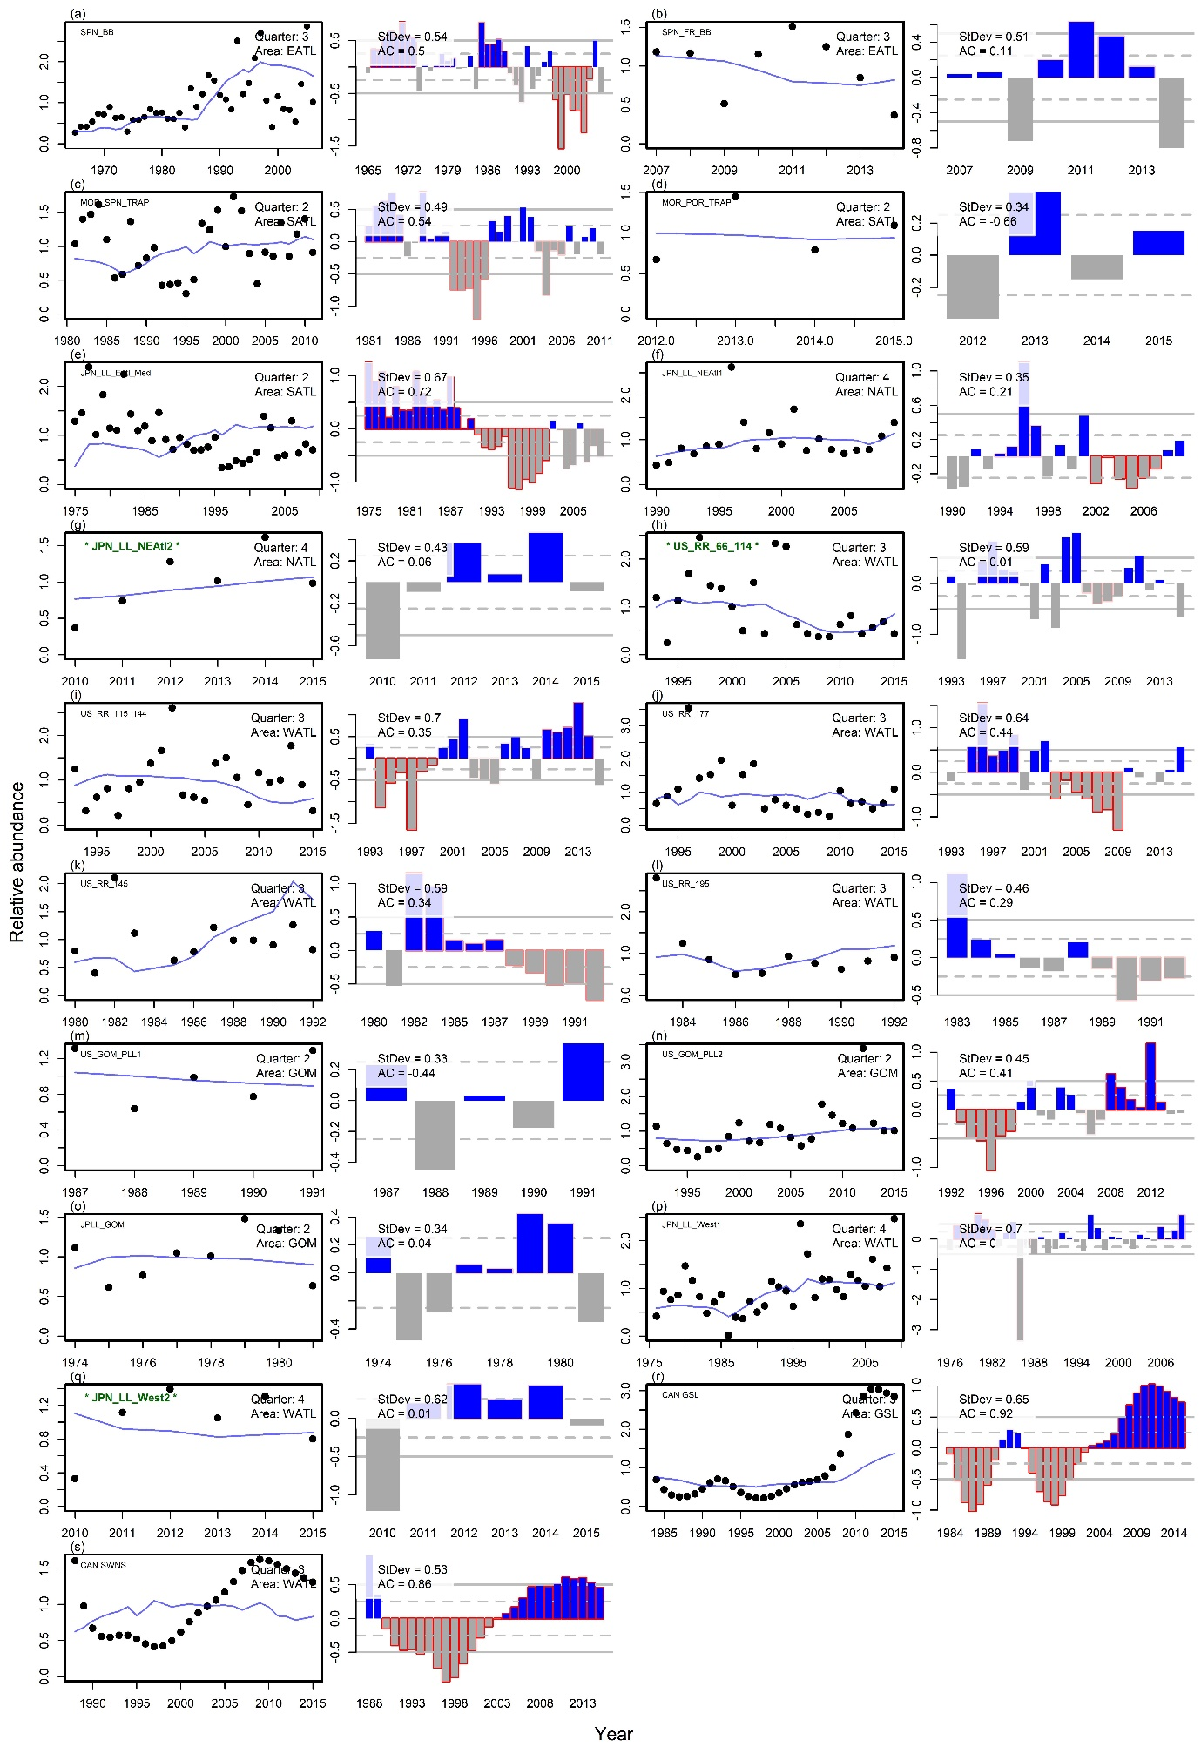

**Figure 2a.** Fit of OM#1 to CPUE indices used in both the stock assessments and the conditioning of these operating models.

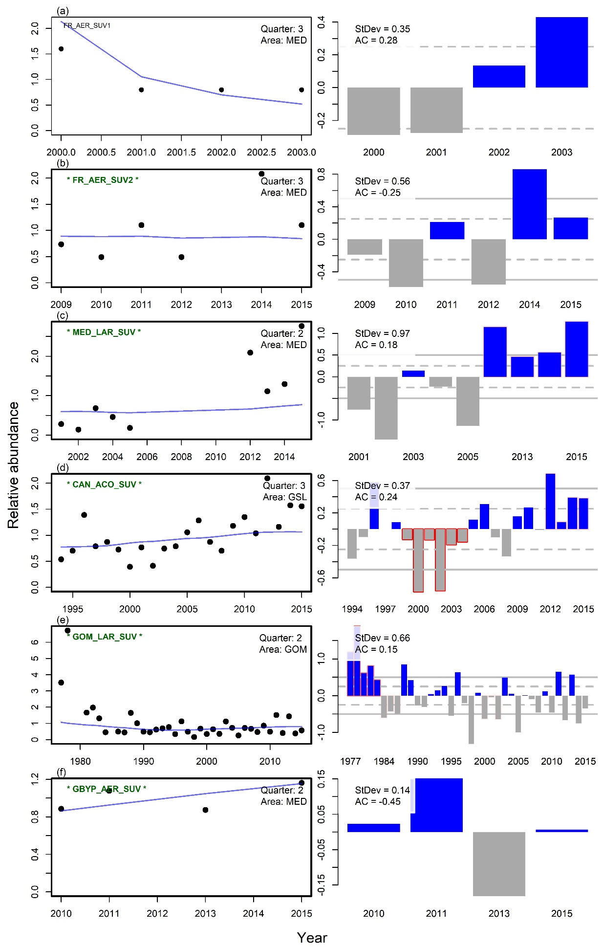

**Figure 2b.** Fit of OM#1 to fishery independent indices used in the stock assessment and the conditioning of these operating models

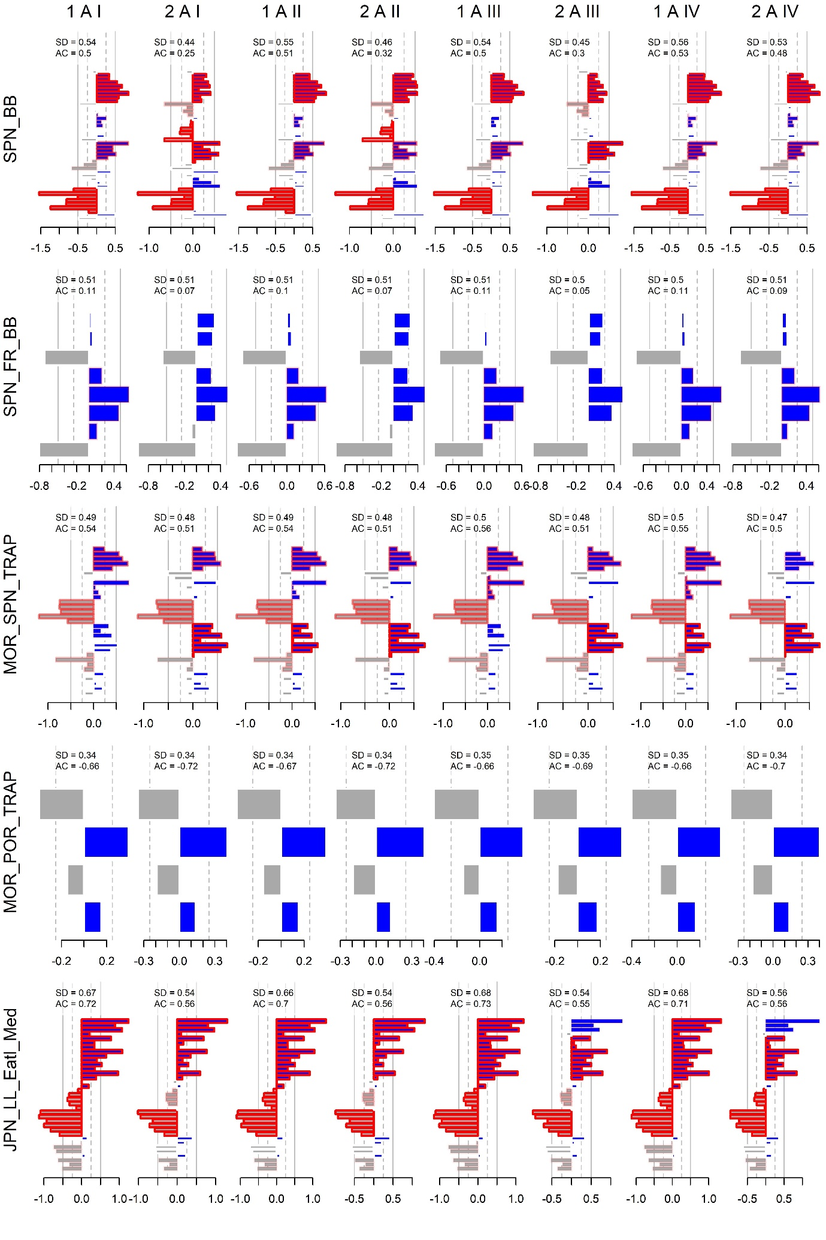

**Figure 3a**. Residuals for all operating model fits (columns) to various assessment indices (rows)

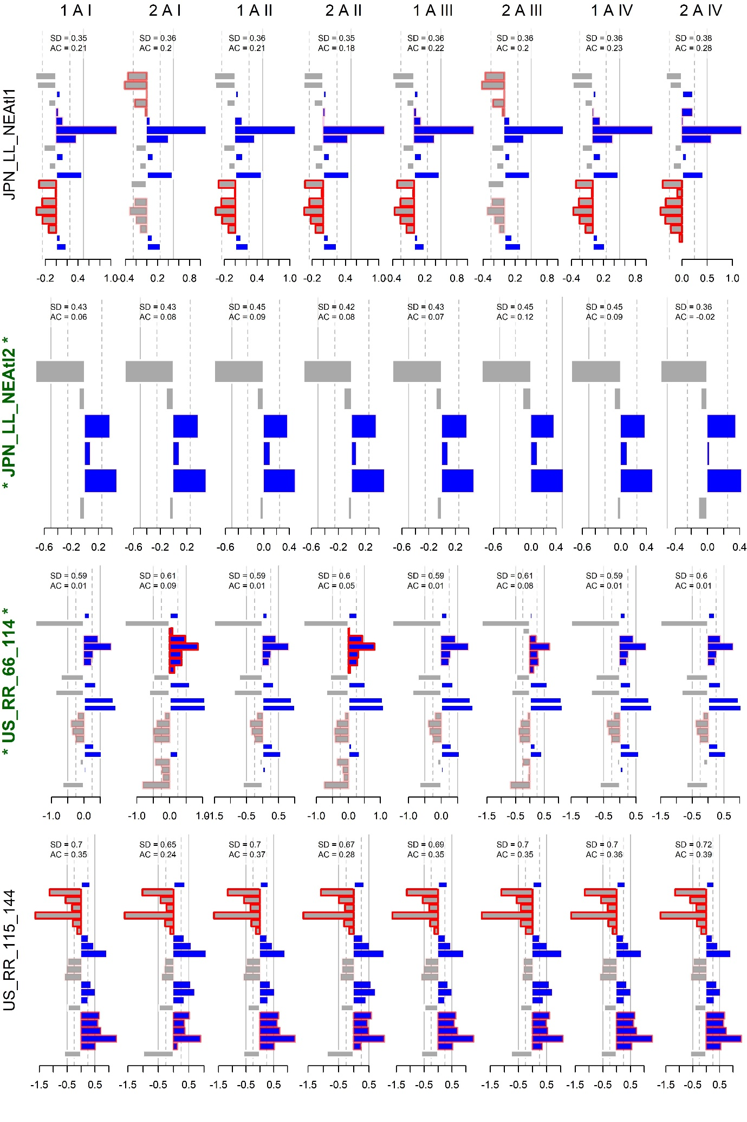

**Figure 3b**. Residuals for all operating model fits (columns) to further assessment indices (rows)

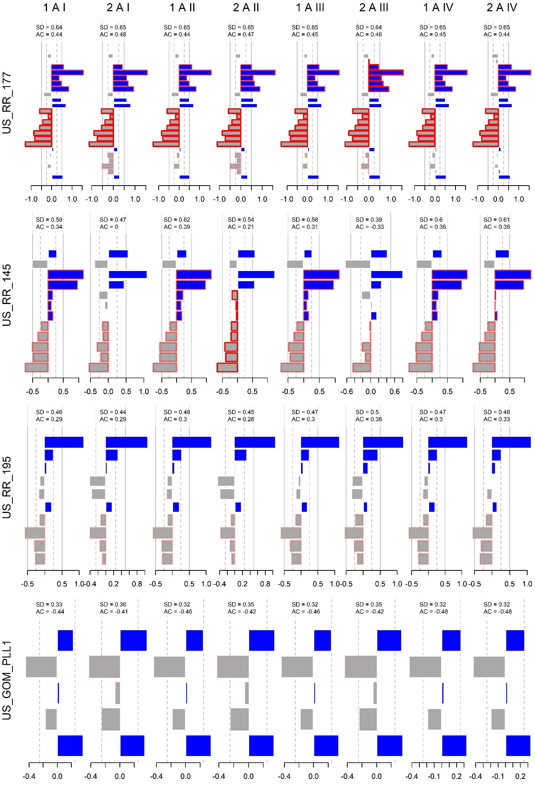

**Figure 3c**. Residuals for all operating model fits (columns) to yet further assessment indices (rows)

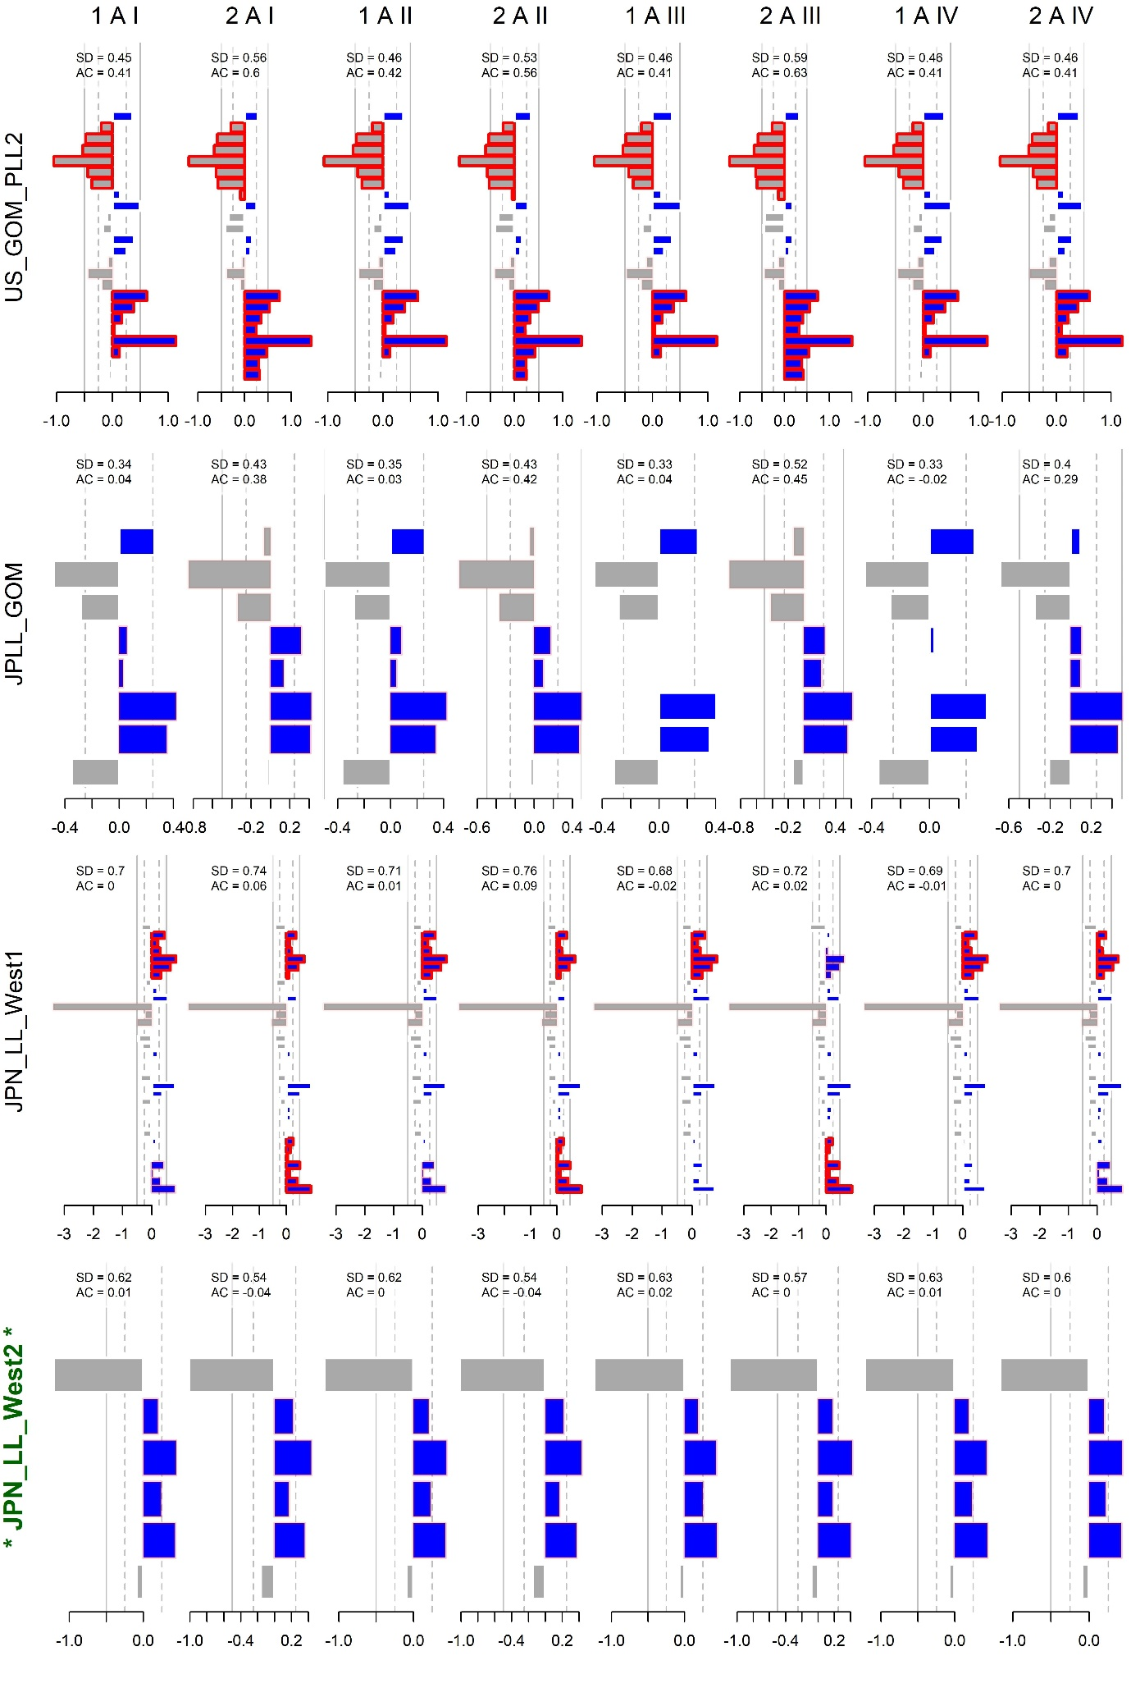

**Figure 3d**. Residuals for all operating model fits (columns) to still more assessment indices (rows)

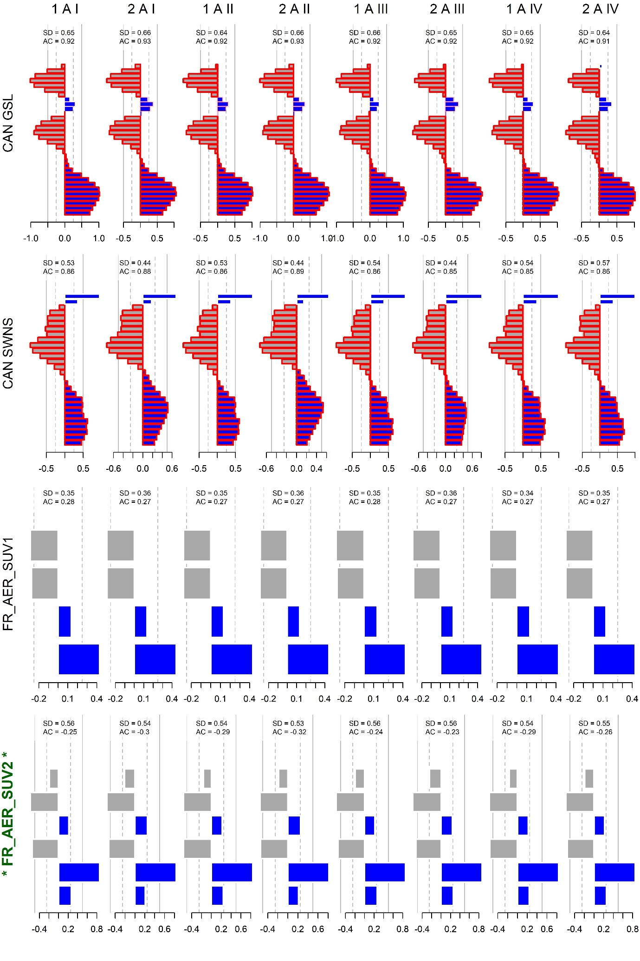

**Figure 3e**. Residuals for all operating model fits (columns) to the still remaining assessment indices (rows)

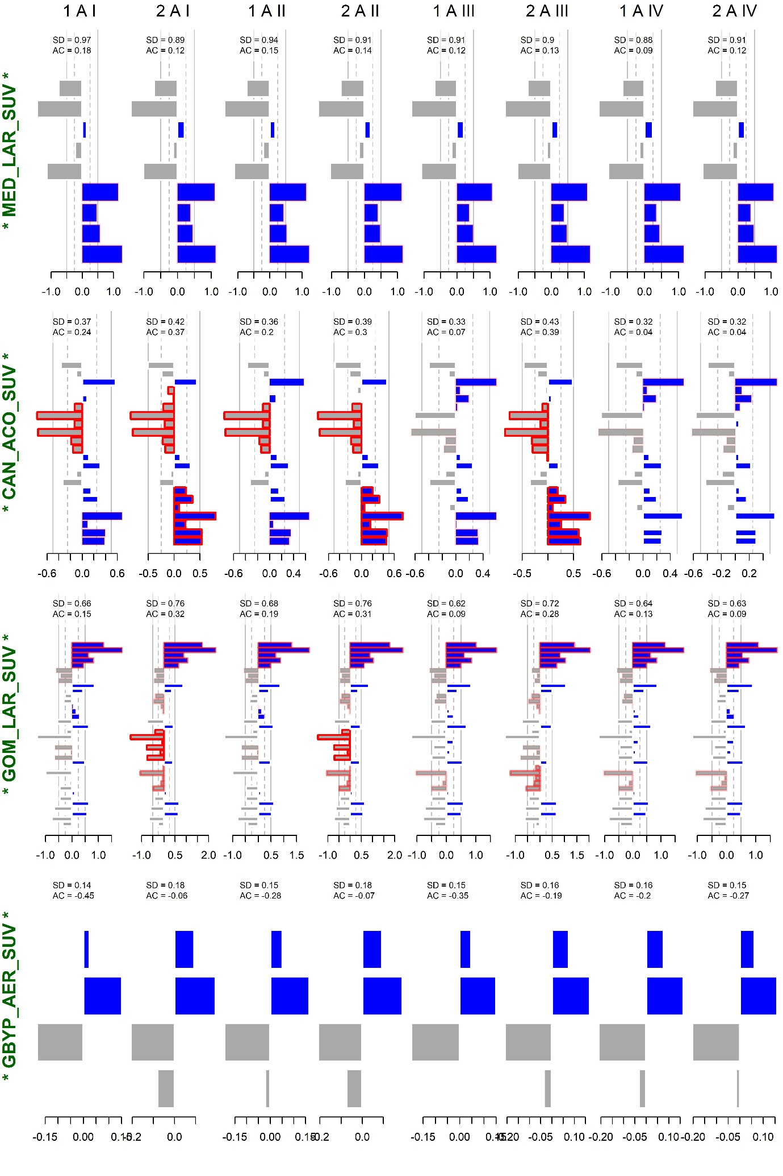

**Figure 3f**. Residuals for all operating model fits (columns) to the still remaining assessment indices (rows)

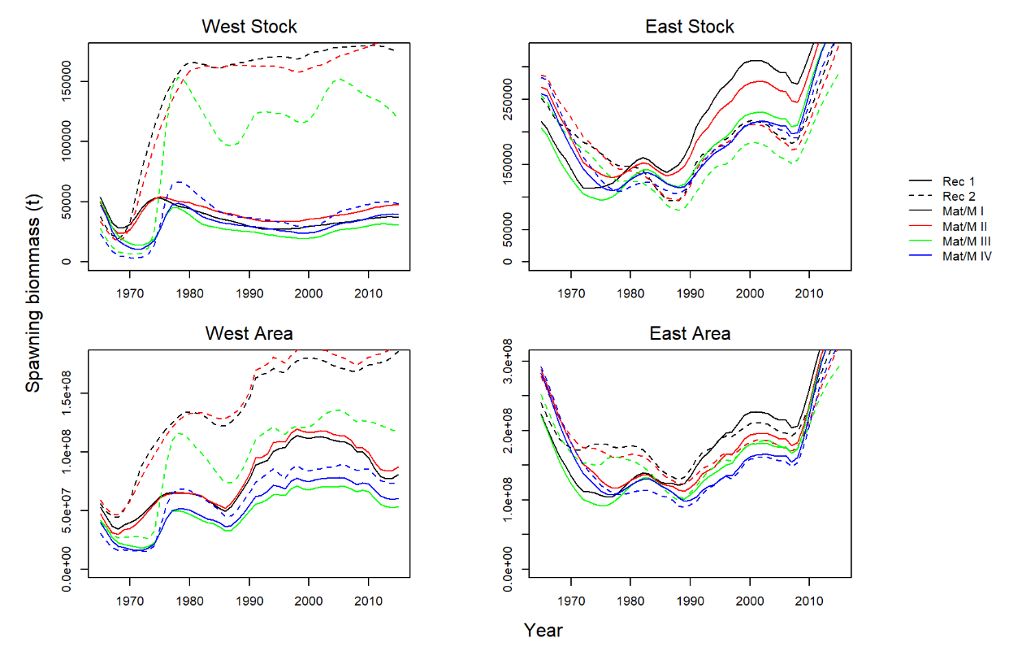

**Figure 4a.** Predicted spawning biomass (East and West stocks) for each factor level A operating model (maximum posterior density estimates) (note that these results differ from those for East and West areas because of stock mixing).

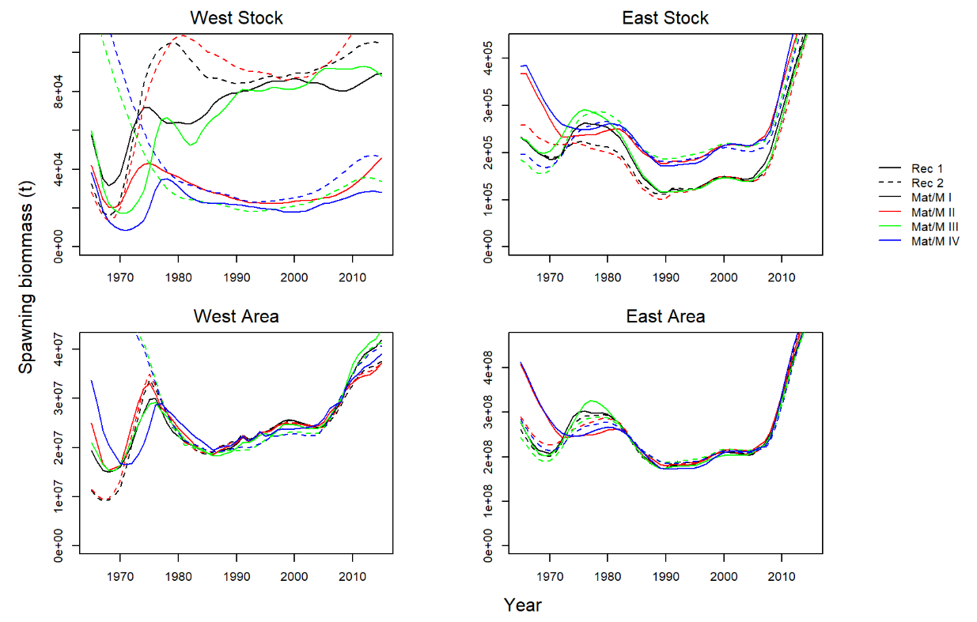

**Figure 4b.** Predicted spawning biomass (East and West stocks) for each abundance factor level B operating model (maximum posterior density estimates) (note that these results differ from those for East and West areas because of stock mixing).

1. IOF, 2202 Main Mall, University of British Columbia, Vancouver, B.C., Canada, V6T 1Z4. [t.carruthers@oceans.ubc.ca](mailto:t.carruthers@oceans.ubc.ca)
2. Dept Maths and Applied Maths, University of Cape Town, Rondebosch 7701, South Africa. [doug.butterworth@uct.ac.za](mailto:doug.butterworth@uct.ac.za)